SPECIAL RELEASE

**Summary Inflation Report**

**Consumer Price Index (2018=100)**

**January 2024**

Date of Release: 13 February 2024

Reference No. SR-2024-02PSO24-04

**Table A. Year-on-Year Inflation Rates, All Items**

**In Percent (2018=100)**

|  |  |  |  |  |
| --- | --- | --- | --- | --- |
| **Area** | **January**  **2023** | **December**  **2023** | **January**  **2024** | **Year-**  **to-date\*** |
| Philippines | 8.7 | 3.9 | 2.8 | 2.8 |
| Davao Region | 9.4 | 5.3 | 4.4 | 4.4 |
| Davao City | 9.6 | 6.5 | 5.6 | 5.6 |

*Source: Retail Price Survey of Commodities for the Generation of Consumer Price Index Philippine Statistics Authority*

* *Year-on-year change of average CPI for January 2023 vs. 2024*

*Source: Retail Price Survey of Commodities for the Generation of Consumer Price Index Philippine Statistics Authority*

**CITY OF DAVAO**

1. **Headline Inflation**

In January 2024, the City of Davao underwent a decrease in headline inflation to 5.6 percent, reflecting a 0.9 percent decline from the December 2023 rate of 6.5 percent. Notably, the current inflation rate was 4.0 percentage points lower than the figure reported in January 2023. Meanwhile, the city's average inflation rate stands at 7.6 percent (Table A and Figure 1).

*1.1 Main Drivers contributing to the Decline Headline Inflation*

Among the 13 commodity groups, the lower headline inflation in January 2024 was primarily brought about by the decrease in the index of (a) Housing, Water, Electricity, Gas and Other Fuels at 0.5 percent, down from 1.1 percent in the previous month. Also contributing to the trend of the headline inflation in the city was (b) Furnishings, Household Equipment and Routine Household Maintenance at 3.1 percent, down from 4.5 percent in the previous month. The third commodity group with the largest contribution to the decreasing trend was (c) Transport at 0.5 percent, which decreased from 1.8 percent in the previous month.

Relative to their annual rates in the previous month, lower year-on-year inflation rates were also observed in the following commodity groups:

1. Alcoholic Beverages and Tobacco, 11.4 percent;
2. Clothing And Footwear, 5.9 percent;
3. Food And Non-Alcoholic Beverages, 8.6 percent;
4. Health, 5.3;
5. Personal Care, and Miscellaneous Goods and Services, 5.2 percent; and
6. Restaurants and Accommodation Services, 13.5 percent;

In contrast, Information and Communication increased by 1.1 percent, up from 1.0 percent the previous month. The rest of the commodities, on the other hand, remained unchanged.

**Table A. Year-on-Year Inflation Rates in Davao City, All Items in Percent**

**January 2021 – January 2024**

**(2018=100)**

|  |  |  |  |  |
| --- | --- | --- | --- | --- |
| **Month** | **Year** | | | |
| **2021** | **2022** | **2023** | **2024** |
| **January** | 1.1 | 5.0 | 9.6 | 5.6 |
| **February** | 1.9 | 4.6 | 10.9 |  |
| **March** | 2.9 | 5.1 | 9.8 |  |
| **April** | 3.6 | 5.1 | 8.8 |  |
| **May** | 3.7 | 6.7 | 7.7 |  |
| **June** | 3.7 | 7.0 | 7.6 |  |
| **July** | 4.2 | 8.4 | 6.3 |  |
| **August** | 4.2 | 9.6 | 4.7 |  |
| **September** | 3.6 | 9.9 | 6.3 |  |
| **October** | 2.8 | 10.4 | 6.6 |  |
| **November** | 4.3 | 10.0 | 6.3 |  |
| **December** | 4.2 | 9.7 | 6.5 |  |
| **Average** | 3.3 | 7.6 | **7.6** | **5.6** |

*Source: Retail Price Survey of Commodities for the Generation of Consumer Price Index Philippine Statistics Authority*

1. **Food Inflation**

Meanwhile, food inflation decreased to 8.6 percent in January 2024 from 9.3 percent in the previous month. The decrease was mainly due to a) Vegetables, Tubers, Plantains, Cooking Bananas and Pulses at -11.1 percent, down from 0.6 percent in the previous month. This was followed by b) Meat and other parts of Slaughtered Land Animals at 4.3 percent, down from 7.2 percent in the previous month; and c) Milk, other Dairy Products and Eggs at 6.2 percent, down from 8.7 percent in the previous month.

Relative to their annual rates in the previous month, lower year-on-year inflation rates were also observed in the following commodity groups:

1. Oils and fats, 11.9 percent; and
2. Ready-Made Food and Other Food Products N.E.C., 6.2 percent.

The rest of the commodities, on the other hand, have increasing rate.

# Purchasing Power of Peso

The Purchasing Power of Peso (PPP) in Davao City for January 2024 remained stable at 0.78 percent, the same as the previous month, as illustrated in Figure 2. Furthermore, to purchase the same set of goods and services valued at Php 100 in 2018, one would require Php 128.5 in January 2024.

*Source: Retail Price Survey of Commodities for the Generation of Consumer Price Index Philippine Statistics Authority*

**Technical Notes:**

**Consumer Price Index (CPI) -** The CPI is an indicator of the change in the average retail prices of a fixed basket of goods and services commonly purchased by households relative to a base year.

**Inflation Rate (IR) -** The inflation rate is the annual rate of change, or the year-on-year change of the CPI expressed in percent. Inflation is interpreted in terms of declining purchasing power of money.

**Headline Inflation** - measures changes in the cost of living based on movements in the prices of a specified basket of major commodities. It refers to the annual rate of change or the year-on-year change in the Consumer Price Index (CPI).

**Purchasing Power of the Peso (PPP) -** The purchasing power of the peso shows how much the peso in the base period is worth in the current period. It is computed as the reciprocal of the CPI for the period under review multiplied by 100.

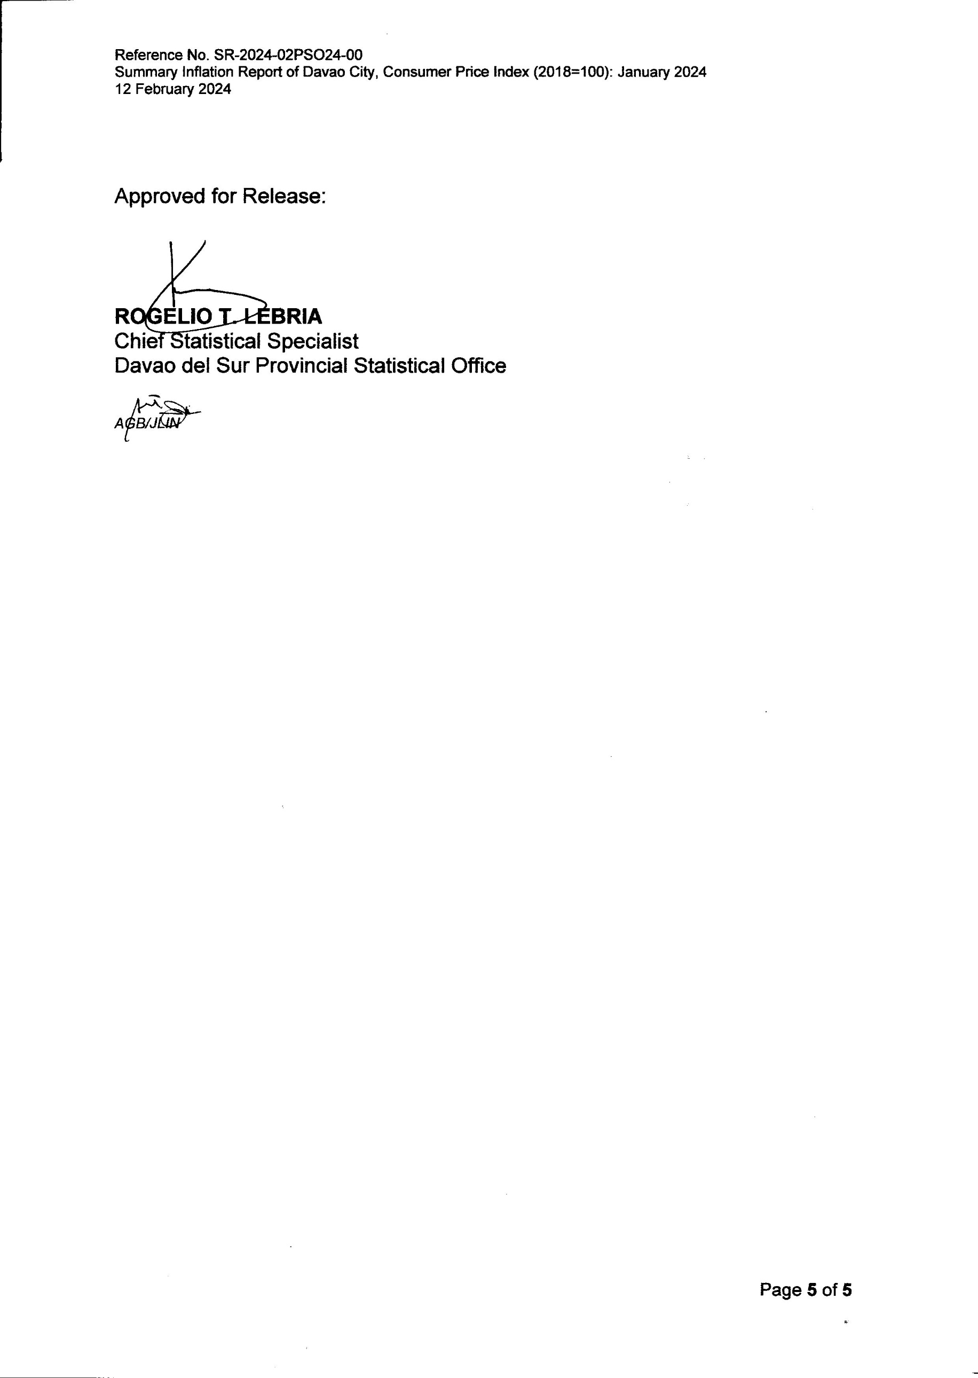

Approved for Release:

# ROGELIO T. LEBRIA

# Chief Statistical Specialist

# Davao del Sur Provincial Statistical Office

# 

# *AGB/JLIN*