SPECIAL RELEASE
Summary Inflation Report
Consumer Price Index (2018=100)
January 2024

Date of Release: 21 February 2024
Reference Number: SR-2024-02PSO24-005

Table A. Year-on-Year Inflation Rates, All Items
In Percent (2018=100)

Area | January  2023 | December  2023 | January  2024 | Year-  to-date*
Philippines | 8.7 | 3.9 | 2.8 | 2.8
Davao Region | 9.4 | 5.3 | 4.4 | 4.4
Davao del Sur | 9.9 | 4.2 | 4.8 | 4.8
Source: Retail Price Survey of Commodities for the Generation of Consumer Price Index Philippine Statistics Authority
- Year-on-year change of average CPI for January, 2023 vs. 2024

Source: Retail Price Survey of Commodities for the Generation of Consumer Price Index,
Philippine Statistics Authority
DAVAO DEL SUR

- Headline Inflation

In January 2024, the headline inflation of Davao del Sur went up to 4.8 percent, which is 0.6 percent higher than it was in December 2023. Compared to January 2023, the current inflation rate is lower by 5.1 percent, when it was at 9.9 percent. (See Table A and Figure 1).

  - Main Drivers Contributing to the Decline Headline Inflation

Among the 13 commodity groups, the increased headline inflation of Davao del Sur in January 2024 was mainly brought about by the increase in the index of (a) Housing, Water, Electricity, Gas, and Other Fuels at 0.6 percent, from negative 1.5 percent in the previous month. Also, there was an increase in the inflation rate of (b) Restaurants and Accommodation Services at 2.2 percent from 0.2 percent in the previous month. The third commodity group with the increased inflation was (c) Furnishings, Household Equipment, and Routine Household Maintenance at 2.7 percent from 2.0 percent in the previous month.

Relative to the annual rates in the previous month, higher year-on-year inflation rates were also observed in the following commodity groups:

- Personal Care, And Miscellaneous Goods and Services, 1.8 percent;
- Health, 3.8 percent;
- Clothing and Footwear, 2.0 percent;
- Alcoholic Beverages and Tobacco, 13.1 percent;
- Recreation, Sport and Culture, 4.1 percent;

In contrast, lower inflation rates were noted for Transport at negative 2.7 percent, from the negative 3.4 percent in the last month, and Food and Non-Alcoholic Beverages at 8.4 percent, from 8.6 percent in December 2023.

Meanwhile, the indices of Education Services (1.8 percent), Information and Communication (0.0 percent), and Financial Services (0.0 percent) remained unchanged.

Table A. Year-on-Year Inflation Rates in the Philippines, All Items
In Percent
January 2020 – January 2024
(2018=100)

Month | Year
 | 2020 | 2021 | 2022 | 2023 | 2024
January | 2.5 | 1.0 | 5.5 | 9.9 | 4.8
February | 2.7 | 1.8 | 5.3 | 9.4
March | 2.1 | 3.0 | 5.8 | 7.2
April | 1.7 | 3.5 | 5.2 | 6.4
May | 1.9 | 3.7 | 6.8 | 5.0
June | 1.9 | 3.7 | 7.4 | 4.6
July | 1.3 | 4.6 | 9.6 | 2.7
August | 0.4 | 6.2 | 8.3 | 3.1
September | 0.5 | 5.7 | 9.9 | 3.3
October | 1.8 | 4.9 | 10.5 | 2.6
November | 0.9 | 5.6 | 11.4 | 1.6
December | 0.5 | 5.4 | 9.8 | 4.2
Average | 1.5 | 4.1 | 8.0 | 5.0 | 4.8

Source: Retail Price Survey of Commodities for the Generation of Consumer Price Index Philippine Statistics Authority

- Food Inflation

The inflation rate of the Food Index decreased from 8.5 percent in December 2023 to 8.3 percent in January 2024. The decrease was mainly due to: (a) Vegetables, tubers, plantains, cooking bananas, and pulses at negative 11.7 percent from 7.7 percent in the previous month. The second food commodity with decreased inflation was (b) Meat and other parts of slaughtered land animals at 0.3 percent, from 2.4 percent in the previous month. This was followed by (c) Sugar, confectionary, and desserts from negative 6.6 percent in December 2023 to negative 8.3 percent in January 2024. And, (d) Milk, other dairy products and eggs with an inflation rate of 14.9 percent, from 15.2 percent in the previous month.

On the other hand, increased year-on-year inflation rates were observed in the following food groups:
- Cereals and cereal products, 18.9 percent;
- Fish and other seafood, 7.4 percent;
- Oils and fats, negative 20.1 percent;
- Fruits and nuts, 37.5 percent; and
- Ready-made food and other food products n.e.c., 9.0 percent.

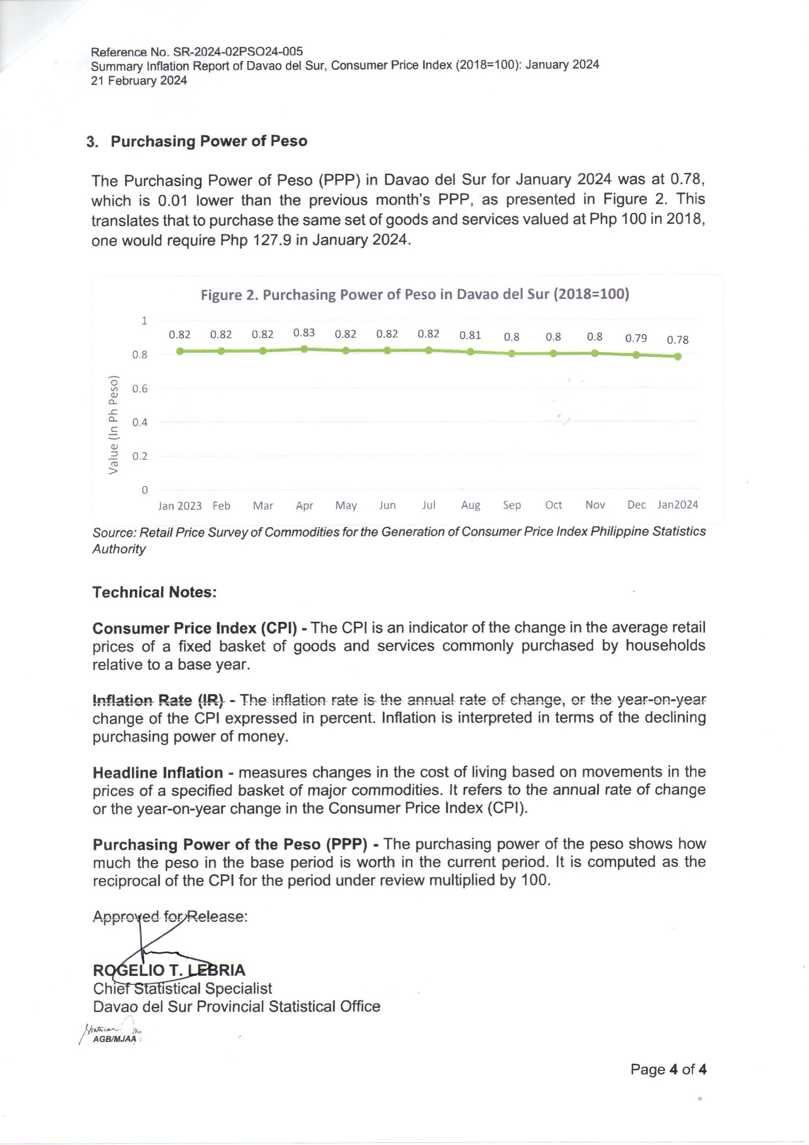
- Purchasing Power of Peso

The Purchasing Power of Peso (PPP) in Davao del Sur for January 2024 was at 0.78, which is 0.01 lower than the previous month’s PPP, as presented in Figure 2. This translates that to purchase the same set of goods and services valued at Php 100 in 2018, one would require Php 127.9 in January 2024.

Source: Retail Price Survey of Commodities for the Generation of Consumer Price Index Philippine Statistics Authority

Technical Notes:

Consumer Price Index (CPI) - The CPI is an indicator of the change in the average retail prices of a fixed basket of goods and services commonly purchased by households relative to a base year.

Inflation Rate (IR) - The inflation rate is the annual rate of change, or the year-on-year change of the CPI expressed in percent. Inflation is interpreted in terms of the declining purchasing power of money.

Headline Inflation - measures changes in the cost of living based on movements in the prices of a specified basket of major commodities. It refers to the annual rate of change or the year-on-year change in the Consumer Price Index (CPI).

Purchasing Power of the Peso (PPP) - The purchasing power of the peso shows how much the peso in the base period is worth in the current period. It is computed as the reciprocal of the CPI for the period under review multiplied by 100.

Approved for Release:

ROGELIO T. LEBRIA
Chief Statistical Specialist
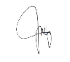
Davao del Sur Provincial Statistical Office
AGB/MJAA

