PSA Davao del Sur, DSWD XI Collaborative Effort for PhilSys Registration of 4Ps Beneficiaries
PRESS RELEASE

Date of Release: 25 April 2024
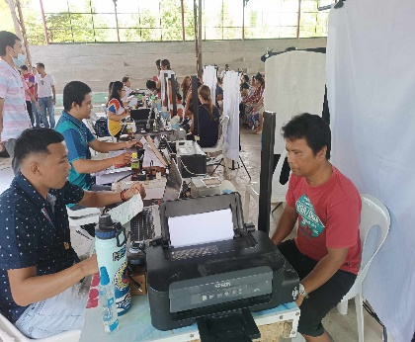
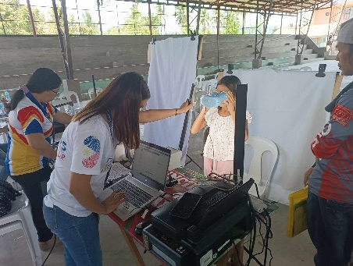
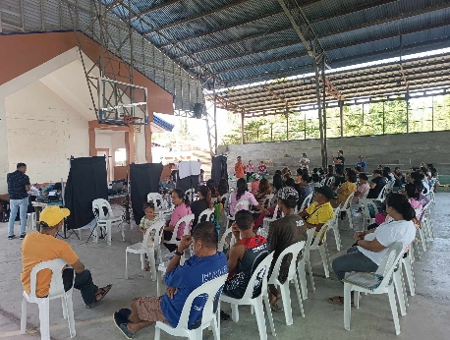
Reference No.: PR-2024-04PSO24-003

Davao City - The Davao del Sur Provincial Statistical Office and the Department of Social Welfare and Development (DSWD) XI have commenced national identification registration for beneficiaries and their household members of the Pantawid Pamilyang Pilipino Program (4Ps).

On 8 March 2024, PSA Davao del Sur and DSWD XI began the first co-location of the national ID registration in Barangay Aplaya, Digos City, Davao del Sur. As of 18 April 2024, a total of 2,321 beneficiaries have been registered for PhilSys. These efforts aim to improve access to government services and enhance social welfare programs.

During the collaborative program, PhilSys personnel assisted beneficiaries with their concerns, particularly those who were already registered but had lost the transaction slip containing the transaction reference number. Additionally, PhilSys personnel assisted beneficiaries who completed national ID registration but had not yet received their PhilID card by providing the ePhilID.

The PSA Davao del Sur and DSWD XI will continue these collaborative efforts until the end of April, ensuring that eligible beneficiaries are given the opportunity to register for the national ID system. Both agencies are committed to address any remaining challenges and providing necessary support to ensure smooth and efficient registration processes across the province.

APPROVED FOR RELEASE:

ROGELIO T. LEBRIA
Chief Statistical Specialist

